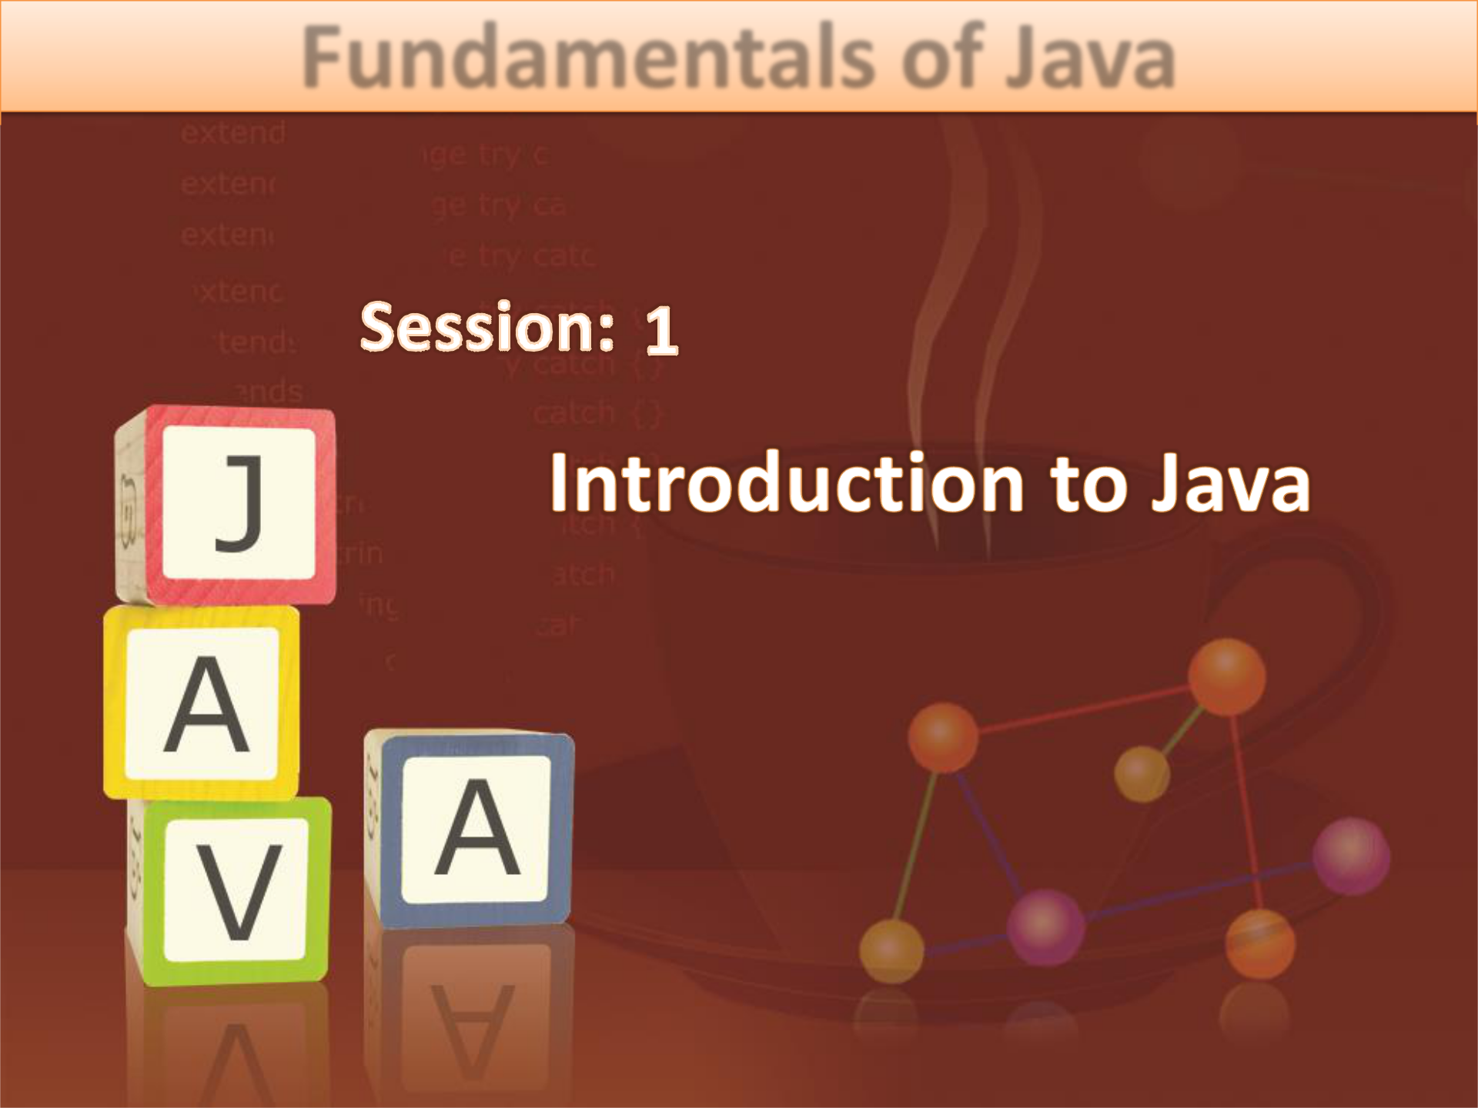
Fundamentals of Java
- Explain the structured programming paradigm

- Explain the object-oriented programming paradigm

- Explain the features of Java as a OOP language

- Describe Java platform and its components

- List the different editions of Java

- Explain the evolution of Java Standard Edition (Java SE)

- Describe the steps for downloading and installing Java Development Kit (JDK)

© Aptech Ltd. Introduction to Java/Session 1 2
- The most prominent use of computers is to

solve problems quickly and accurately.

◆ The solution adopted to solve a problem is provided as a sequence of instructions or specifications of activity which enabl s a user to achieve the desired result.
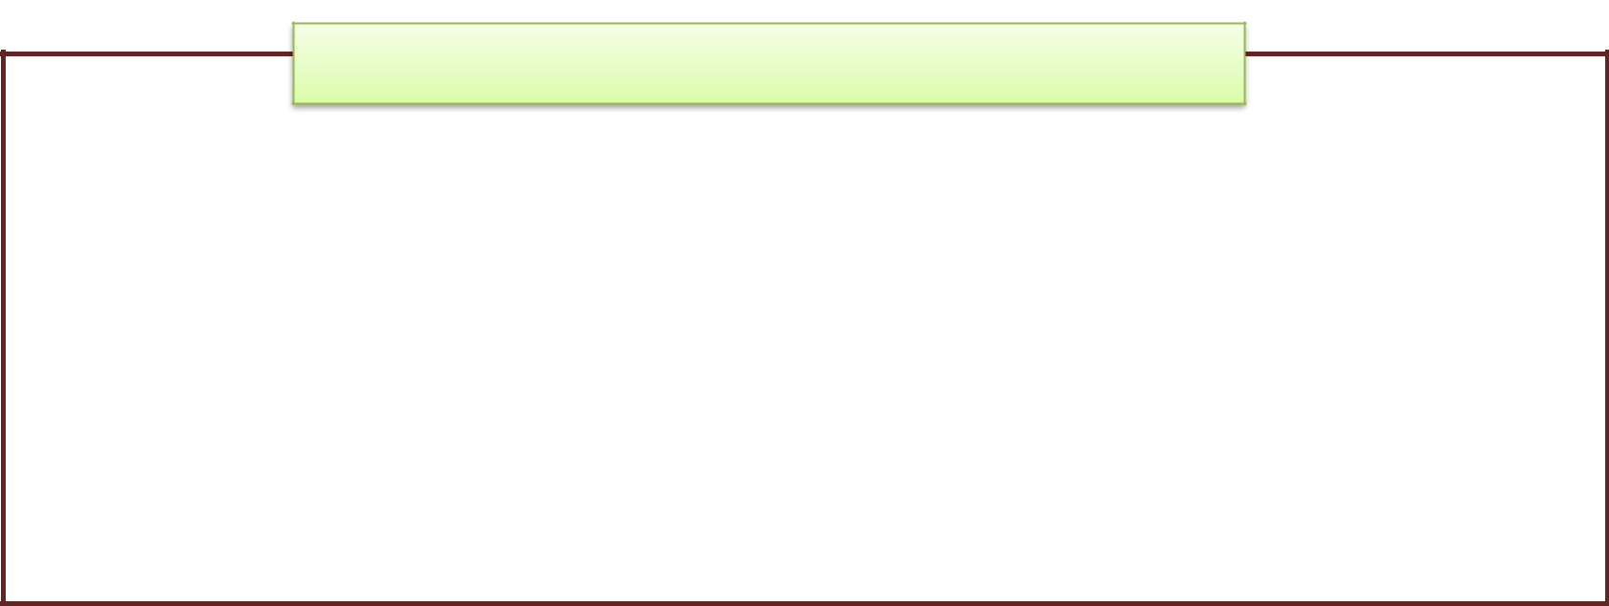

Software Applications

- The solution for solving a problem in the field of information technology is achieved by developing software applications.

- A softwa e application can be defined as a collection of pr grams that are written in high-level programming languages to solve a particular problem.

© Aptech Ltd. Introduction to Java/Session 1 3
- Knowledge of Domain:

  - It plays an important role while developing software applications.

  - It can be defined as the field of business or t chnology to which a problem belongs.

  - Following figure shows the Centredevelopmof software application as a solution for managing various opera ions in a banking domain:
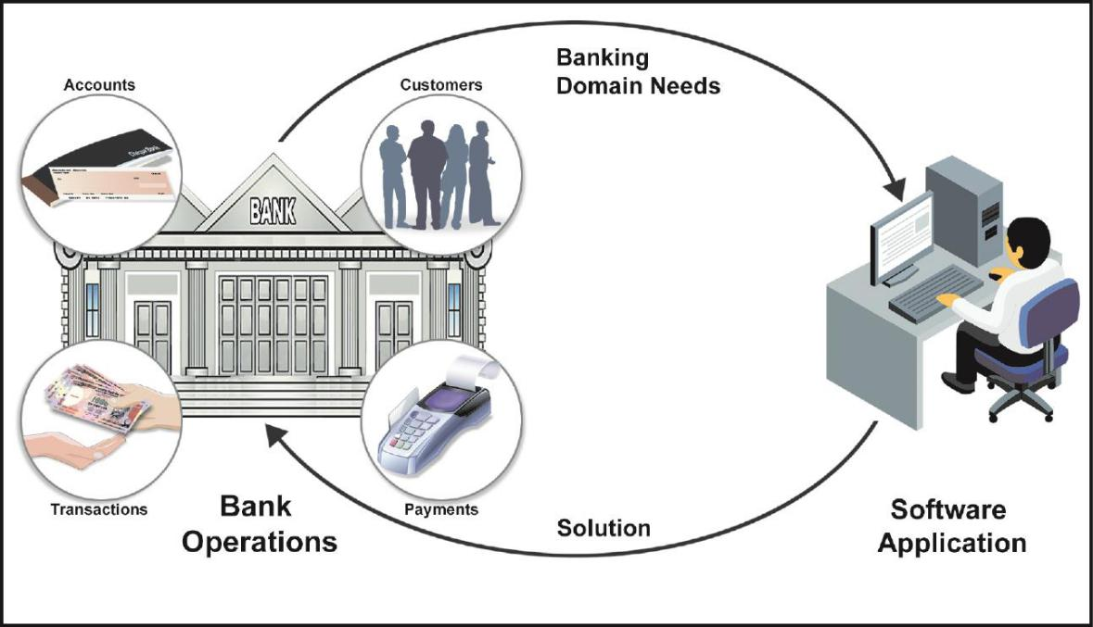

© Aptech Ltd. Introduction to Java/Session 1 4
- Programming Languages:

  - The development of software application is done using a programming language.

  - A programming language is used as a medium for communicating the instruction to the computer.

  - The programming language enforces a particular style of programming that is referred to as a programmi g paradigm.

  - Following are the two types of programming paradigm:


Structured Object-oriented
Programming Programming
Paradigm Paradigm

© Aptech Ltd. Introduction to Java/Session 1 5
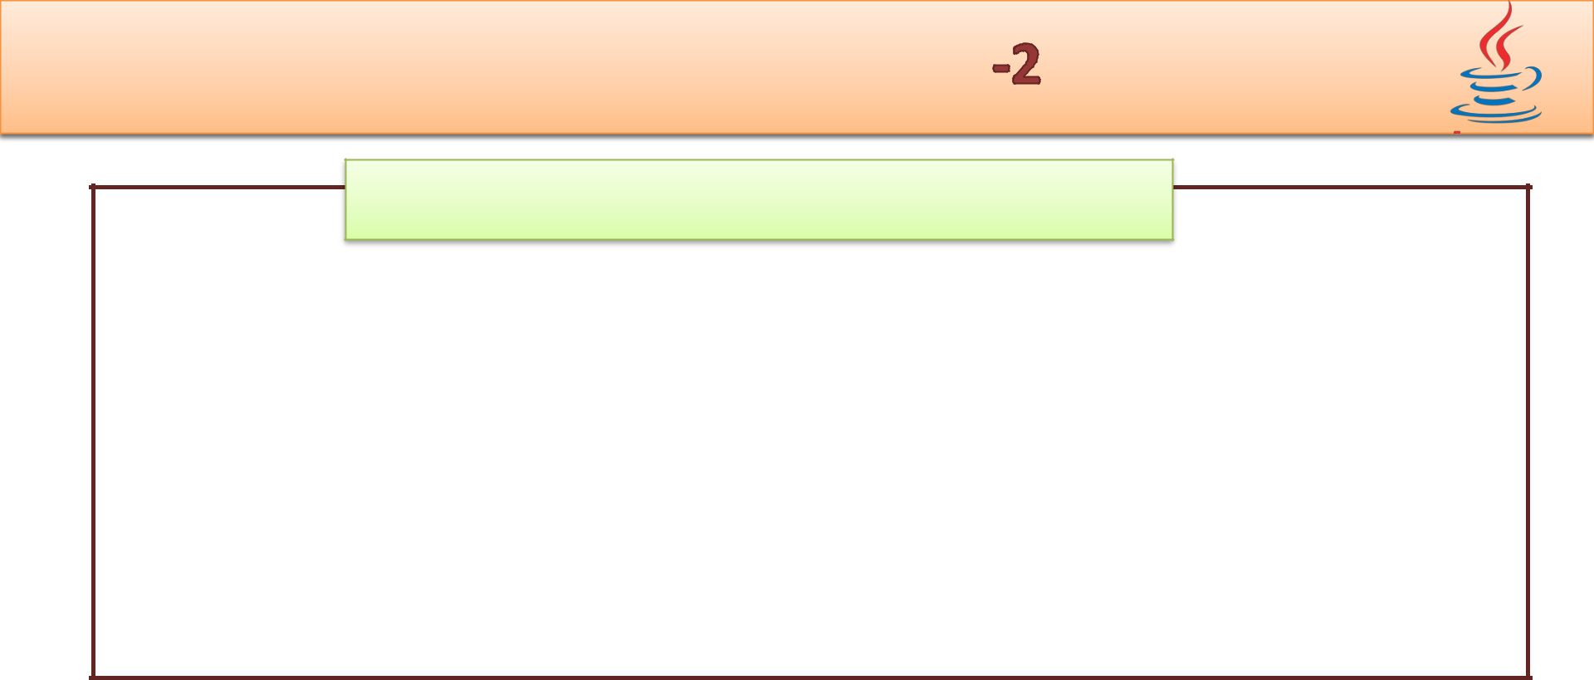
Structured Programming

  - In structured programming paradigm, the application development is decomposed into a hierarchy of subprograms.

  - The subprograms are referred to as procedures, functions, or modules in different structured prog amming languages.

  - Each subprogram is defined to perfo m a specific task.

  - Some of structured programmi g la guages are C, Pascal, and Cobol.

- Following figure displays bank application activities broken down into subprograms:
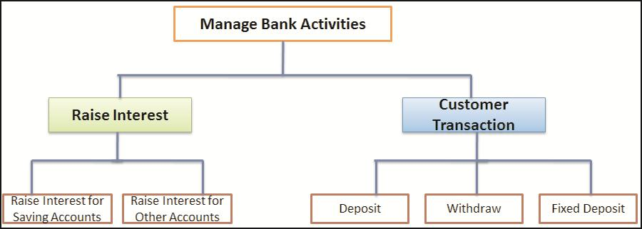

© Aptech Ltd. Introduction to Java/Session 1 6
- Main disadvantage of structured programming languages are as follows:

    - Data is shared globally between the subprograms.

    - Efforts are spent on accomplishing the solution rather than focusing on problem domain.

  - This often led to a software crisis, as the maintenance cost of complex applications became high and availability of reliable software was educed.
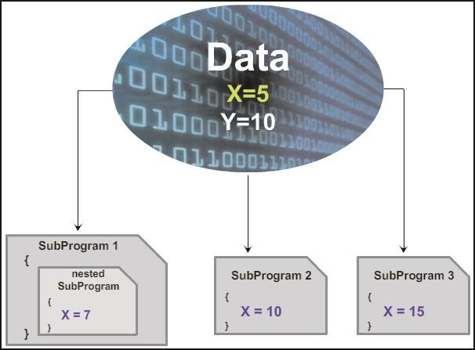

© Aptech Ltd. Introduction to Java/Session 1 7
- Growing complexity of software required change in programming style.

- Some of the features that_{Centre}wereaimed are as follows:

  - Development of reliable sof wa at reduced cost.

  - Reduction in the maintenance cost.

  - Development of reusable software components.

  - Completion of software development with the specified time interval.

- These featu es resulted in the evolution of object-oriented programming paradigm.

© Aptech Ltd. Introduction to Java/Session 1 8
- The software applications developed using object-oriented programming paradigm is:

  - Designed around data, rather than focusing only on the functionalities.

- Following shows different activiti s involved in the object-
oriented software developme :
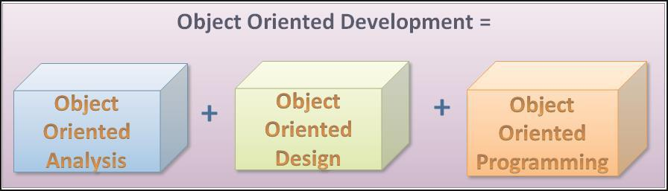

© Aptech Ltd. Introduction to Java/Session 1 9
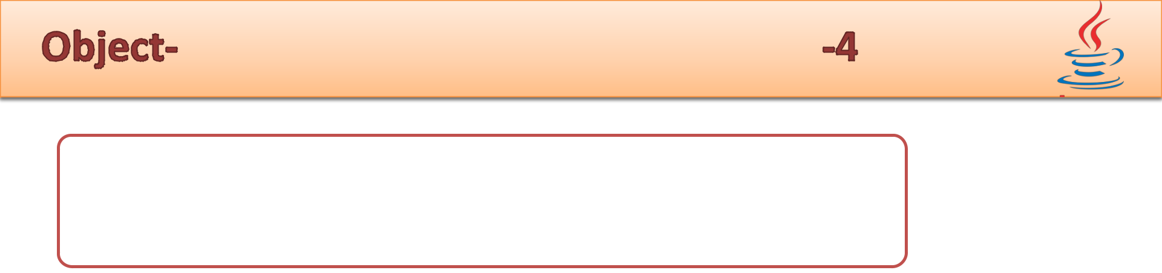

Object-oriented Analysis (OOA) phase determines
the functionality of the system.
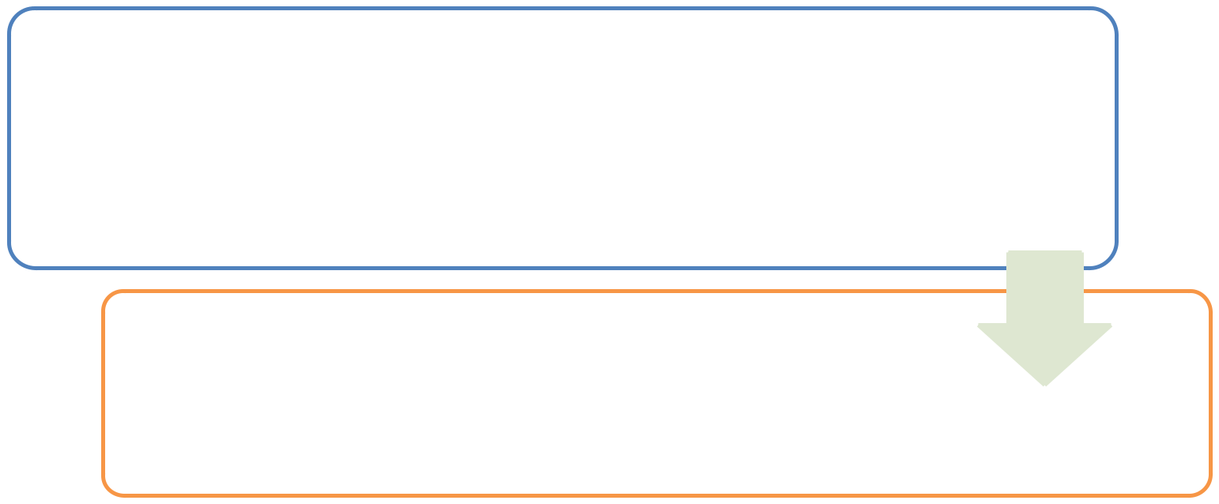

Object-oriented Design (OOD) phas s determines the process of planning a syst m in which objects interact with each o her to solve a software problem.

Object-oriented Programming (OOP) deals with the actual impl mentation of the application.

- Unified Modeling Language (UML) helps to create visual models in the system.

- The actual implementation of these visual models is done using an OOP language.

© Aptech Ltd. Introduction to Java/Session 1 10
- An OOP language is based on certain principles that are as follows:

  - Object – Represents an entity which possessUsec rtain features and behaviors.

  - Class – Is a template that is used to create objects of that class.

  - Abstraction – Is a design technique hat focuses only on the essential features of an entity for a specific problem domain.

  - Encapsulation – Is a mechanism that combines data and implementation details into a single unit called class.

  - Inheritance –AptechEnablesedeveloper to extend and reuse the features of existing classes and r ate new classes. The new classes are referred to as derived classes.

  - Polymorphism – Is the ability of an object to respond to same message in different ways.

© Aptech Ltd. Introduction to Java/Session 1 11
- An object represents a real-world entity.

- Any tangible or touchable entity in the real -world can be described as an object.

- Following figure shows some real-world entities:
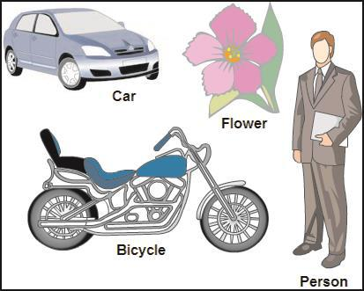

© Aptech Ltd. Introduction to Java/Session 1 12
- Each object has:

    - Characteristics – Defined as attributes, properties, or features describing the object.

    - Actions – Defined as activities or operations performed by the object.

  - Example of an object, Dog.

      - Properties – Breed, Color, and Age

      - Actions – Barking, Eating, and Running

  - The concept of objects in the real-world can be extended to the prog amming world where software ‘objects’ can be defined.


© Aptech Ltd. Introduction to Java/Session 1 13
- A software object has state and behavior.

- ‘State’ refers to object’s characteristics or attributes.

◆ ‘Behavior’ of the software object compri its actions.

- Following figure shows a software object, a Car with its state and behavior:
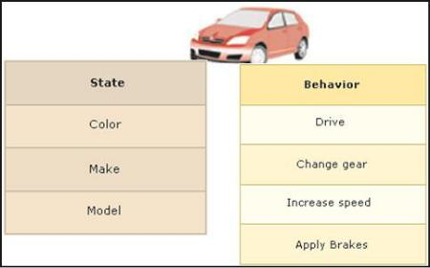

© Aptech Ltd. Introduction to Java/Session 1 14
- The advantages of using objects are as follows:


1

2

- They help to understand the r al -world.

- They map attributes and actions of real-world entities with state a d behavior of software objects.

© Aptech Ltd. Introduction to Java/Session 1 15

◆ Class:
- In the real-world, several objects:

  - Have common state and behavior.

  - Can be grouped under a single class.

  - Example: All car objects have attributes, such as color, make, or model.

 Can be defined that a class isCentreatempla or blueprint which defines the

state and behavior for all obj cts belonging to that class.

 Following figure shows a car as a template and a Toyota car as an object or instance of the class:
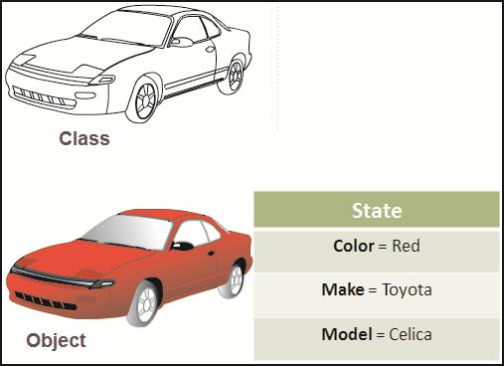

© Aptech Ltd. Introduction to Java/Session 1 16
- Class comprises fields and methods, collectively ca ed as members.

  - Fields – Are variables that depict the state of obj cts.

  - Methods – Are functions that depict the behavior of objects.
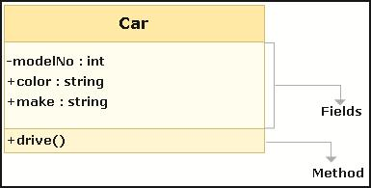

© Aptech Ltd. Introduction to Java/Session 1 17
- Following table shows the difference between a c ass and an object:

Class | Object
Class is a conceptual model | Object is a real thing
Class describes an entity | Object is the actual entity
Class consists of fields (data | Object is an instance of a class
members) and functions

© Aptech Ltd. Introduction to Java/Session 1 18
- It is one of the most popular OOP language.

- It helps programmers to develop wide range of applications that can run on various hardware and Operating System (OS).

- It is also a platform that creates an environment for executing Java application.

- It caters to small-scale to large-scale problems across the Internet.

- Java applications are built on variety of platforms that range from:

  - Embedded devices o d sktop applications

  - Web applications to mobile phones

  - Large business applications to supercomputers


© Aptech Ltd. Introduction to Java/Session 1 19
◆ Java Origins: Embedded Systems


• Team of engineers from Sun Microsystems wanted to design a language for consumer devices.

• Project was named as ‘Green Project’.

• Team included: James Gosling, Mike Sheridan, and
1991 | Patrick Naughton.
1991 | • Efforts were tak to produce portable and a platform
 | independent language that can run on any machine.

- Result was evolution of Java.

- Initially alled ‘OAK’ and later renamed to Java .

© Aptech Ltd. Introduction to Java/Session 1 20
- Java Wonder: Internet
  - Internet and Web started emerging and was used worldwide.

  - Sun Microsystems turned Java into an Int rnet

1995 | programming language.
  - It emerged as a Web technology that added dynamic capabilities to the Web pag s.

- Java Moved: Middle-tier
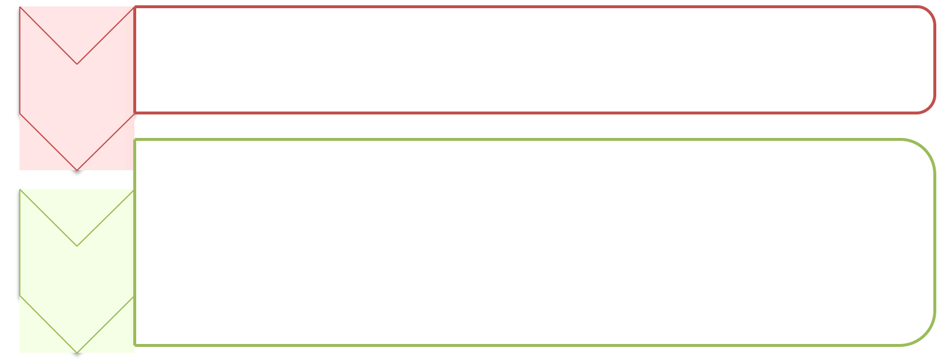

1997

2006

  - Sun Microsystems defined Servlets API to generate dynamic HTML for Web pages and Enterprise JavaBeans for developing business logics.

- Sun Microsystems released three versions for free under General Public License (GPL)

- These are: Java Platform, Standard Edition (Java SE), Java Platform, Enterprise Edition (Java EE), and Java Platform Micro Edition (Java ME)

© Aptech Ltd. Introduction to Java/Session 1 21

- Java Ahead: Acquisition
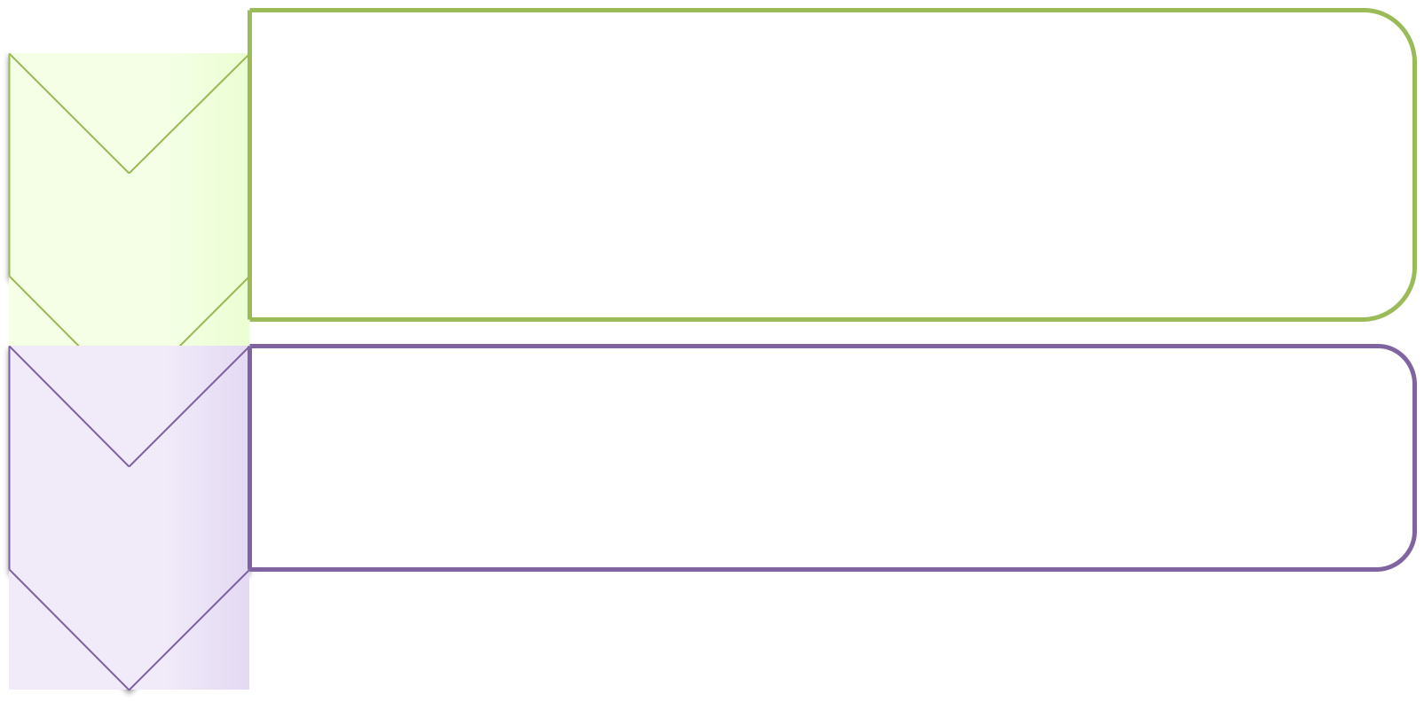

2009

2010

- Sun Microsystems was acquired by Oracle Corporation.

- The project Coin was launched to enhance Java programming language.

- Java EE 6 was released with simplified development and deployment model.

- The specification for Java 7 was approved by the Java Community Process (JCP).

© Aptech Ltd. Introduction to Java/Session 1 22

- Java is a high level OOP language as well a platform used for developing applications that can be executed on different platforms.

- It is characterized by following features:
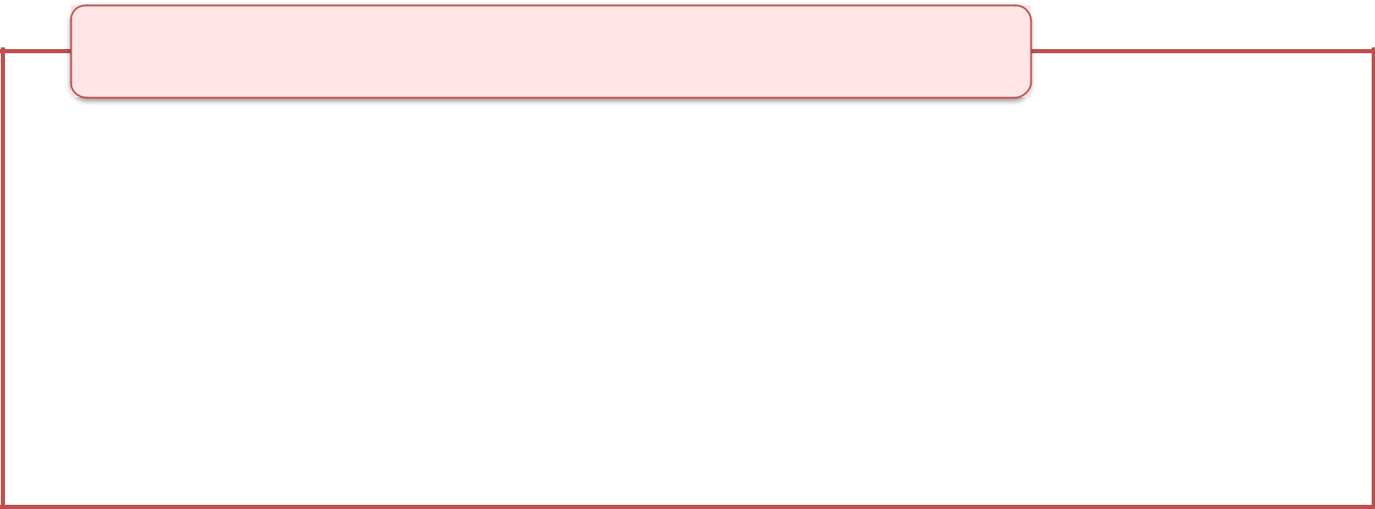

Simple

- Inherits its syntax from predecessor p ogramming languages, such as C/C++.

- Helps programmers to adapt to Java language without any extra skills and extensive trainings.

- Eliminates the use of pointers, operator overloading, and multiple inheritance features supported by predecessor languages.

© Aptech Ltd. Introduction to Java/Session 1 23
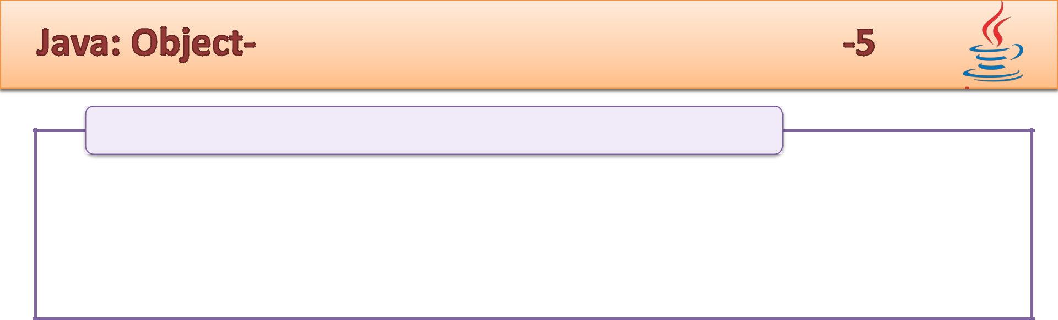
Object-oriented

- Java is a pure OOP language that uses classes and objects that address to the real-world problem domains.

- Even, the application development in Java tarts with a class designing.
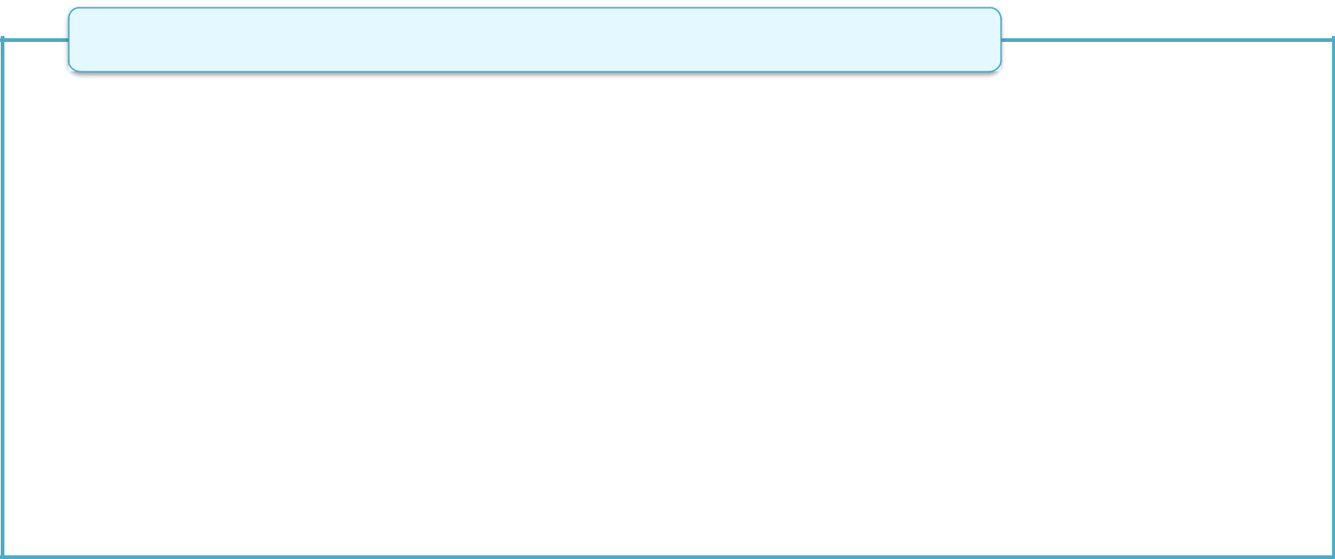

Robust

- C and C++ languages - Dynamic memory allocation/deallocation is done manually through pointers that resulted in memory related errors.

- Java incorporates:

  - Strong memory manag m nt - Handles memory allocation and deallocation using Garbage Collection Mechanism that destroys unused objects in memory automatically.

  - Exception handling mechanism - Stops abnormal termination of code at runtime.

  - Compile-time checking – Ensures variables are declared which contain specific type of data.

  - Run-time checking – Ensures purity of Java code during execution.

© Aptech Ltd. Introduction to Java/Session 1 24
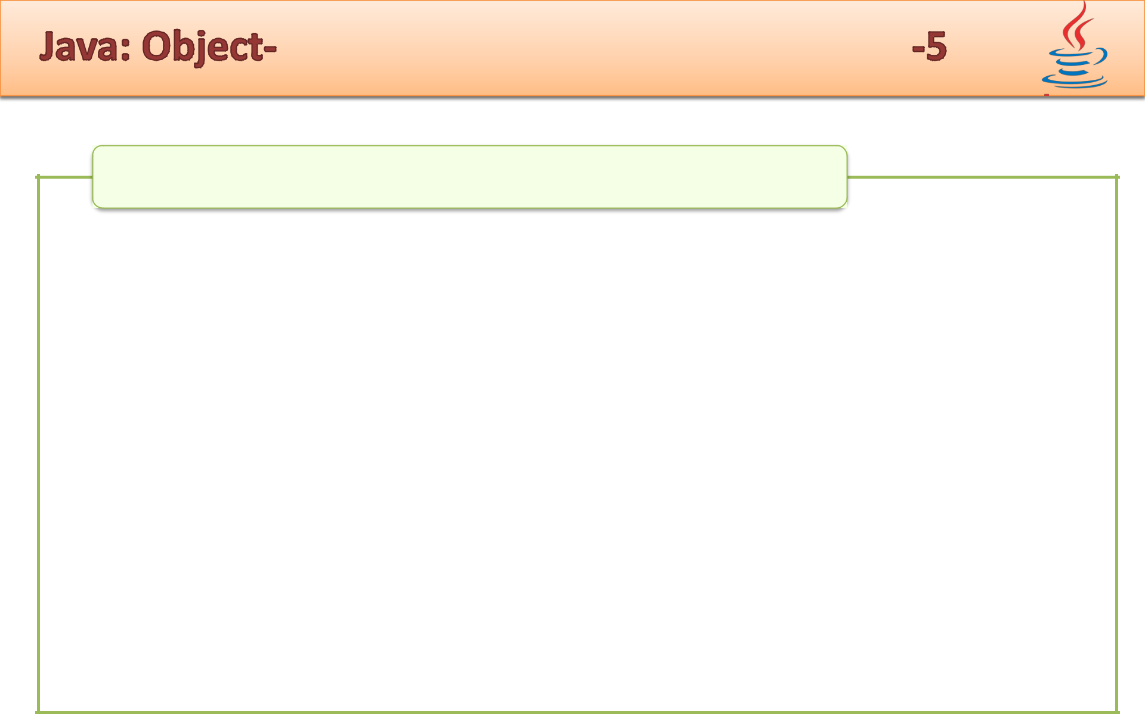

Secure

- Security checks applied at different layers en ures that the Java programs are protected against malicious codes.

- Java programs that are accessed on the n twork are known as applets.

- Java applies security to applets by placing them in a sandbox that ensures it should not have dir ct access to files or resources available on the local system.

- Java Virtual Machine (JVM) which is a runtime environment for executing Java programs applies its own security features to Java language.

- JVM ensures that the code loaded for execution is well-formed and conforms to Java standards.

© Aptech Ltd. Introduction to Java/Session 1 25
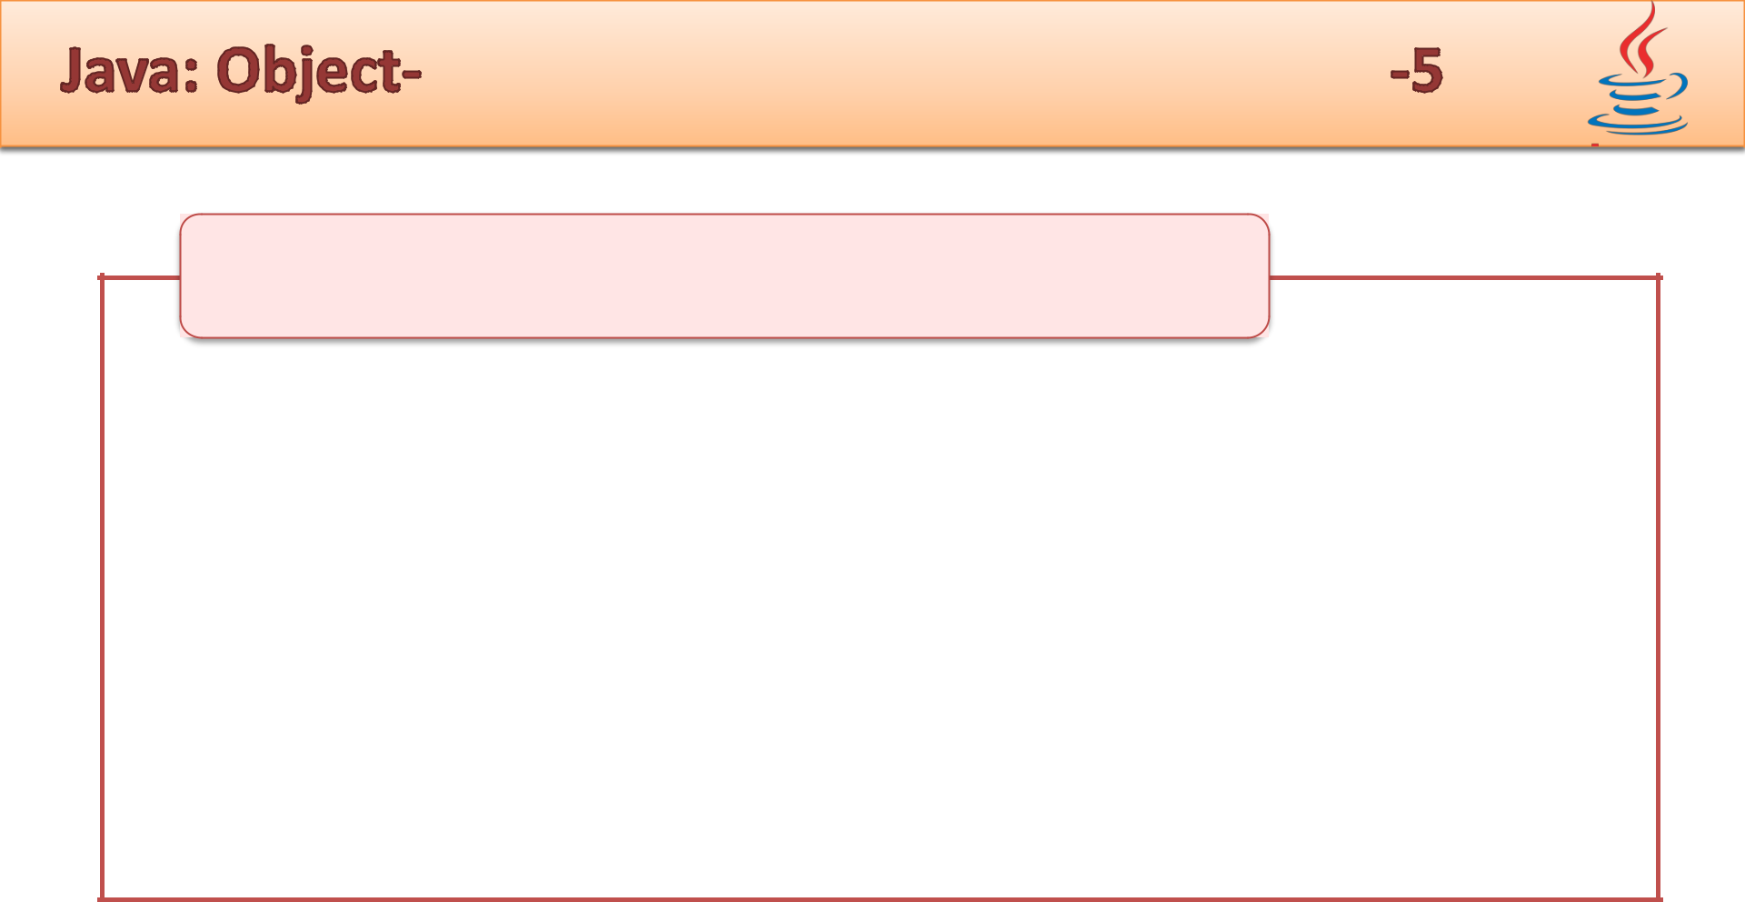

Architecture Neutral and Portable

• Supports portability by converting application into architecture neutral bytecode during compilation.

• Java has defined language_{Centre}specifications, such as size of primitive data types and operato s hat are independent of the hardware platform.

• For example, an integer variable in Java always occupies 32 bits
on whichever machine the code is executed.
• These featuresAptechsatisfies major goal of Java language which is ‘Write once, run anywhere’.

Multithreaded

• Allows a single program to perform multiple tasks simultane usly with different threads.

© Aptech Ltd. Introduction to Java/Session 1 26
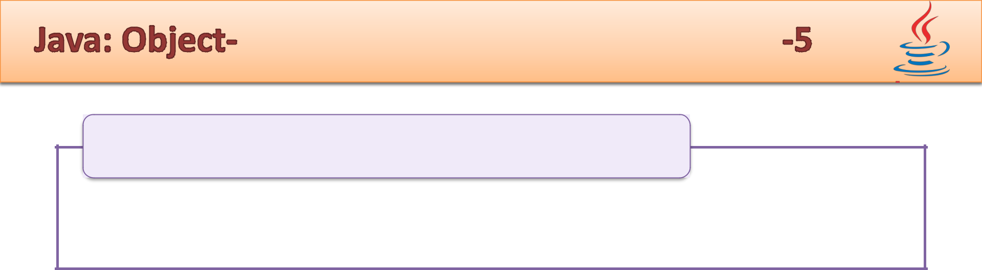

Distributed

- Supports distributed programming in which r sources can be accessed across the network.
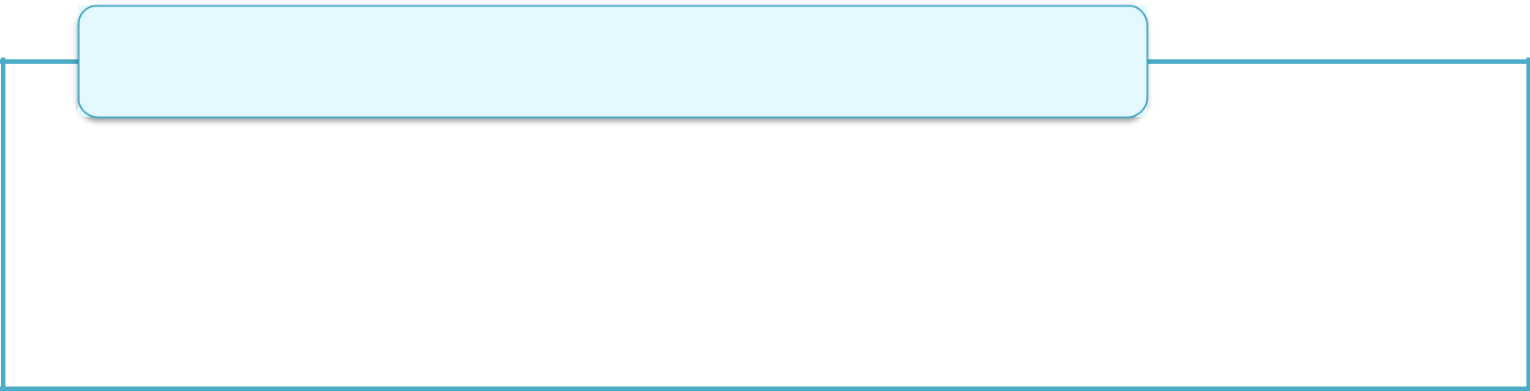

Dynamic

- At runtime an application can dy amically decide which classes it requires and loads them accordingly.

- This gives new perspective to Java for designing and developing applications.

© Aptech Ltd. Introduction to Java/Session 1 27
- Is a software-only platform that runs on top of other hardware-based platforms.

- Contains Java Runtime Environment (JRE) with components namely:

  - Java Virtual Machine (JVM)

  - Java class library also ref rr d to as Java Programming Interface (Java API)

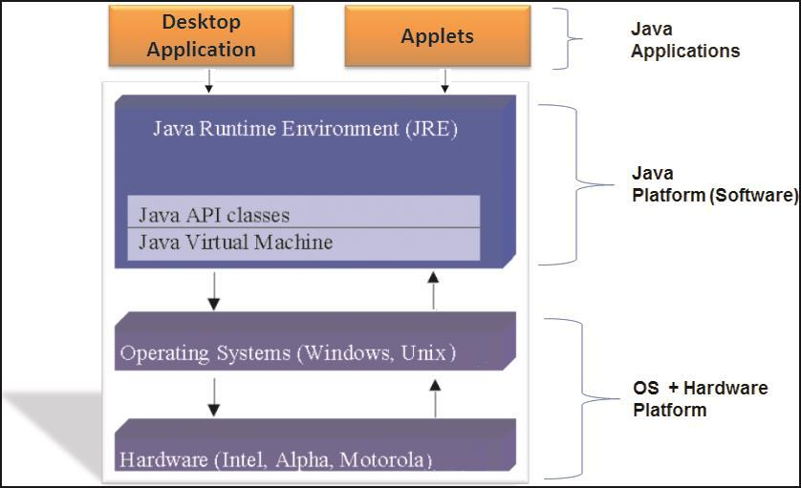

© Aptech Ltd. Introduction to Java/Session 1 28
- It is an executable engine that creates an enviro ment for executing Java compiled code, that is, bytecode.

- It is known as a virtual machine because it is an imitation of a Java processor on the physical machine.

- There are different implementations of JVM available for different platforms, such as Wi dows, Unix, and Solaris.

© Aptech Ltd. Introduction to Java/Session 1 29
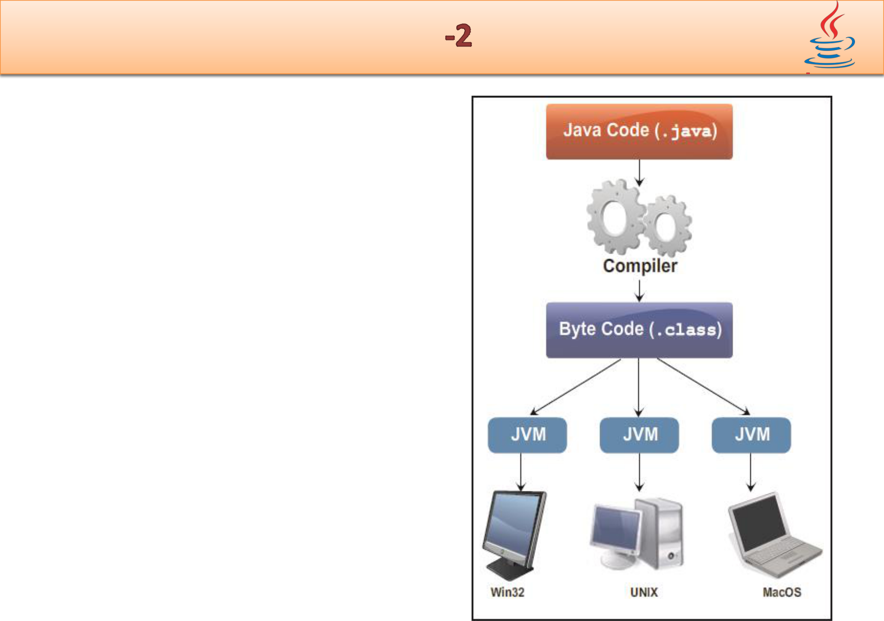
- Bytecode:

  - Is an intermediate form closer to machine representation.

  - Is an optimized set of instructions executed by the Java runtime environment.

  - This environment is known as JVM.

- The same bytecode can be executed by different implementations of JVM on various platforms.

© Aptech Ltd. Introduction to Java/Session 1 30
- It is a large collection of ready-made software components.

- These components are classes and interface grouped into libraries referred to as packages in Java.

- Example:

  - The Swing library provides classes for Us r Interface (UI) components.

  - The Input/Output (I/O) library provides the standard interface for reading and writing data into files stor d in the system.

© Aptech Ltd. Introduction to Java/Session 1 31
- Java Standard Edition (Java SE) - Is a base platform and enables to develop console and networking applications for desktop computers.

- Java Enterprise Edition (Java EE) - Is built on top of Java SE platform and provides a standard specification for developing and deploying distributed, scalable, and multi-tier enterprise applications.

- Java Mobile Edition (Java ME) - Is a robust platform for developing embedded Java applications for consumer electronic devices, such as mobiles, Personal Digital Assistants (PDAs), and TV set-top boxes.

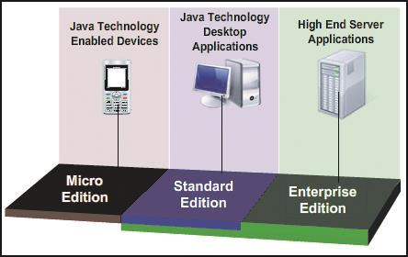

© Aptech Ltd. Introduction to Java/Session 1 32
- Provides two software components:

  - JRE

    - JRE provides JVM and Java libraries that are used to run a Java program.

  - JDK

    - Known as Java Development Kit (JDK).

    - Is a binary software development kit released by Oracle Corporation.

    - Is an implementation of Java and distributed for different platforms, such as Windows, Linux, Mac OS X, and so on.

    - Contains a comprehensive set of tools, such as compilers and debuggers that are used to develop Java applications.

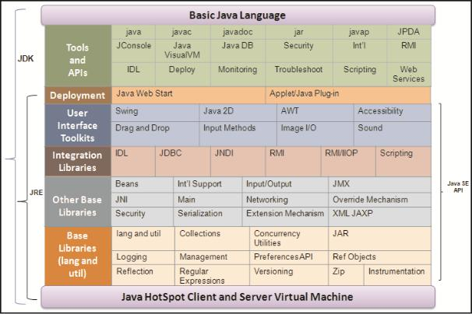

© Aptech Ltd. Introduction to Java/Session 1 33
- Development Tools – Include tools used for compi ing, running, debugging, and documenting a Java application.

- API - Provides the core functionality of the Java programming language.

- Deployment Tools – Provid s software for deploying the developed applications to end-users.

- User Interface Toolkits - Enables the developer to create graphical interfaces in a Java application.

- Integration libraries - Enable developers to access and manipulate database and remote objects in an application.

© Aptech Ltd. Introduction to Java/Session 1 34
 | Table lists the | different releases of JDK.
 | Releases | Implementation
 | JDK 1.0 | Creation of packages with classes in the standard library
 | JDK 1.1 | Included an event delegation mod | l for Graphical User
 |  | Interface (GUI) package AWT, JavaBeans, and Java
 |  | Database Connectivity (JDBC) API
 | JDK 1.2 (Java 2) | Included a new graphical API, named Swing. Also, added
 |  | APIs for reflection a d collection framework (based on data
 |  | structure)
 | JDK 1.3 | Included a directory interface to lookup for components,
 |  | named, Java Naming and Directory Interface (JNDI)
 | JDK 1.4 | Included regular expression API, assertions, exception
 |  | chaining, channel-based I/O API, an XML API for parsing
 |  | and rocessing
 | JDK 1.5 | Included new features in the language such as for-each
 |  | loop, generics, annotations, and auto-boxing
 | JDK 1.6 | Included script language, visual basic language support, and
 |  | improvements in the GUI
© Aptech Ltd. |  | Introduction to Java/Session 1 | 35
- Java SE 7 is the new major release of Java with i ternal version number as 1.7.

- The lists of new features that are incorporat d in the language are as follows:

  - Supports the use of String class in the switch decision-making construct.

  - Integer types can be assigned with a binary number value.

  - Supports the use of underscore character ( _ ) between the digits of a numeric value.

  - An expandable try statement called try-with-resources statement used for automatic resource management.

  - Constructor of a generic class declaration can be replaced with an empty set of parameters (<>).

  - Enhancement in exception handling mechanism. In exception handling code, a single catch can be used to handle one or more exceptions.

  - Compiler warnings generated for varargs methods has been improved.

© Aptech Ltd. Introduction to Java/Session 1 36
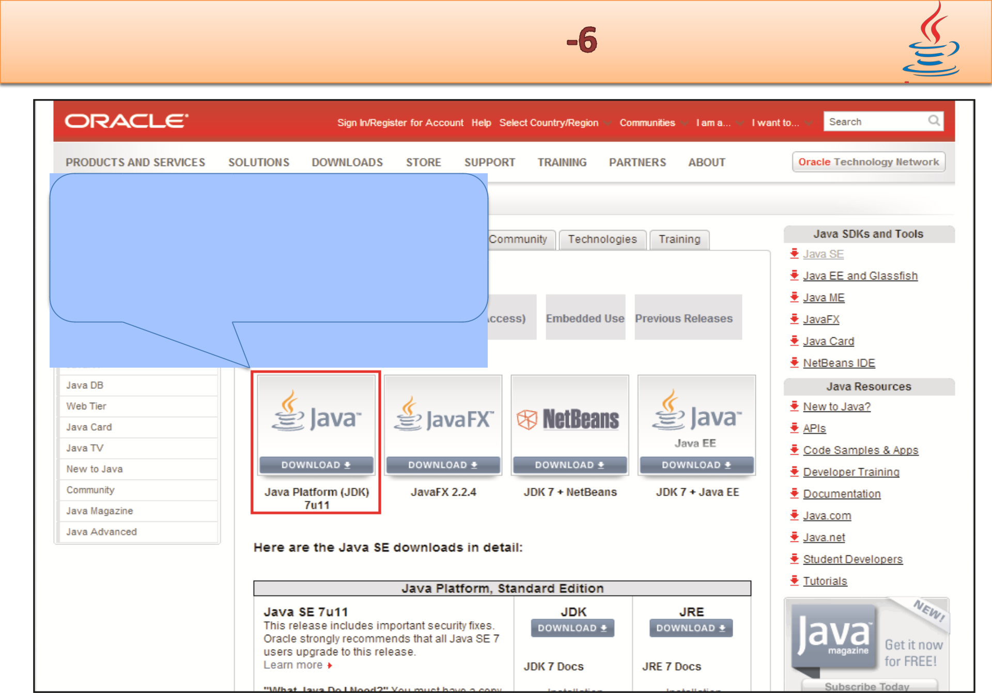

On Oracle site, click
Download button to install

the JDK on download page

© Aptech Ltd. Introduction to Java/Session 1 37
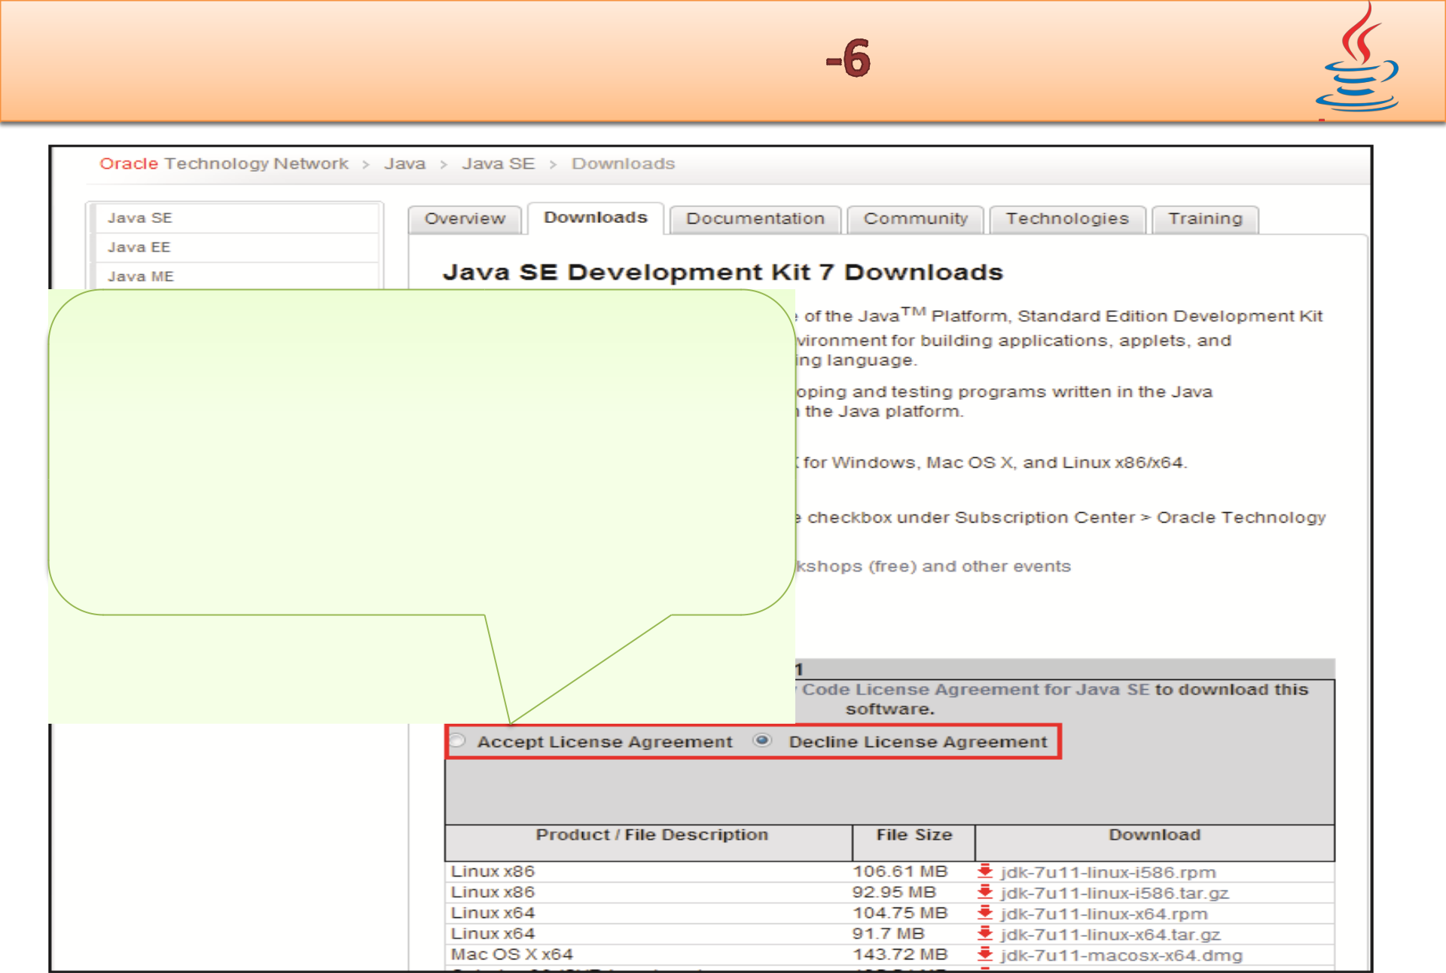

On Java SE Development Kit 7
Downloads Web page, click
Accept License Agreement.
The agreement outlines that the
user agrees to Oracle by
installing the JDK

© Aptech Ltd. Introduction to Java/Session 1 38
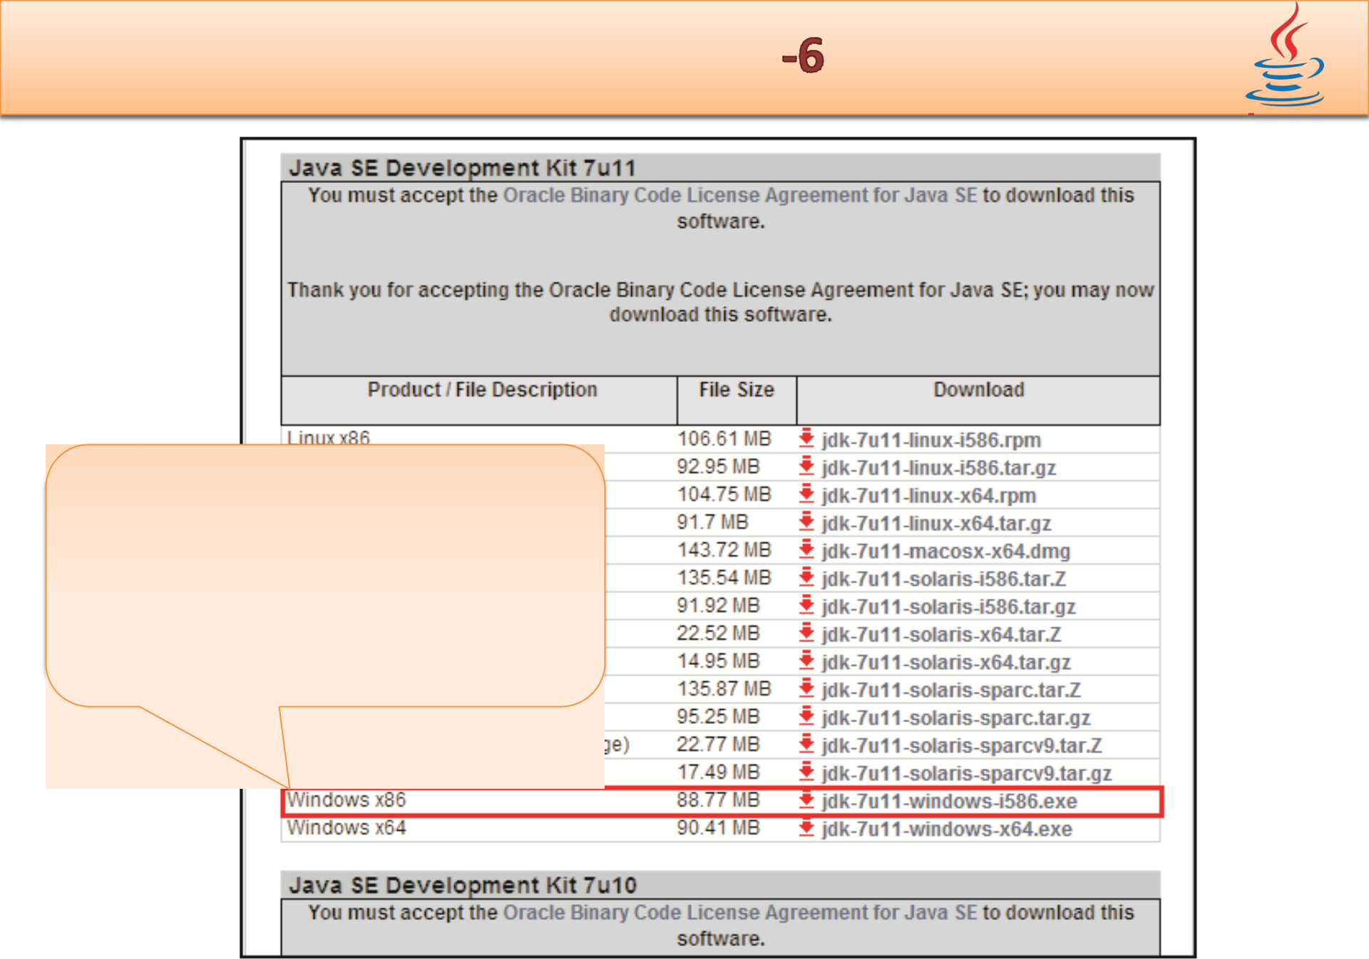

To download JDK 7 for
Windows 32-bit OS, click
jdk-7u11-windows-
i586.exe under
Download

© Aptech Ltd. Introduction to Java/Session 1 39
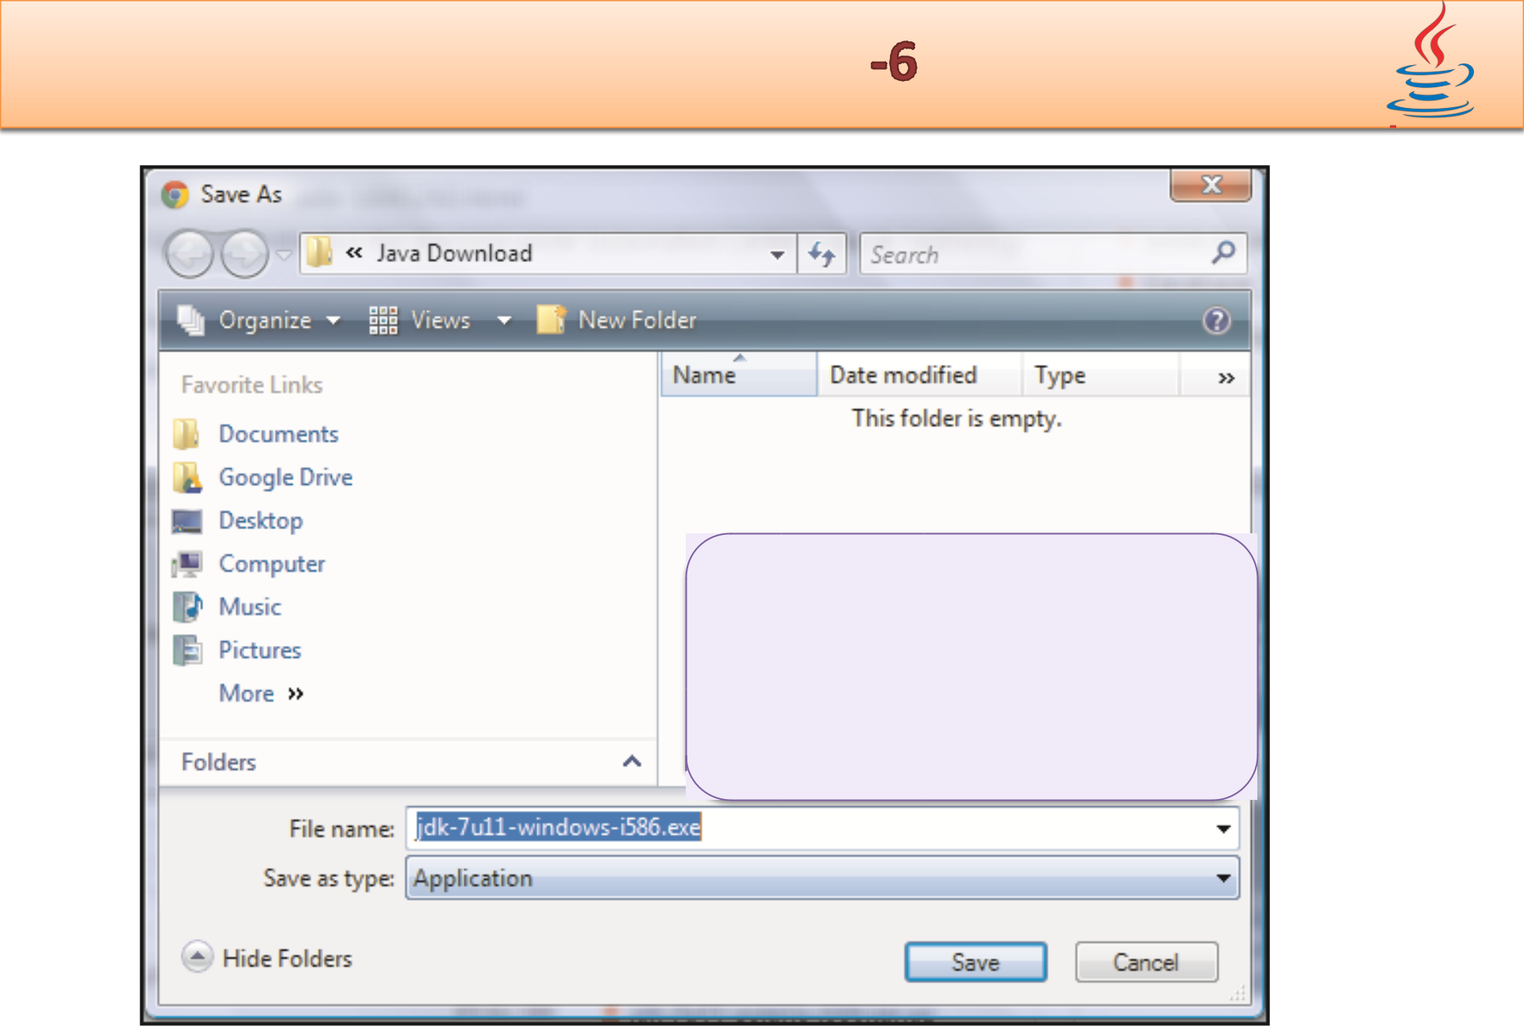

In the Save As dialog
box, select the location
to save the JDK
installer and then, click
Save

© Aptech Ltd. Introduction to Java/Session 1 40
- Double-click the installer icon and follow the instructions provided by the JDK installer.

- The installer installs development tools, ource code, and the JRE in the default directory, C:\Program Files\Java.

- Following figure shows the directo y structure of the installed JDK on the system:
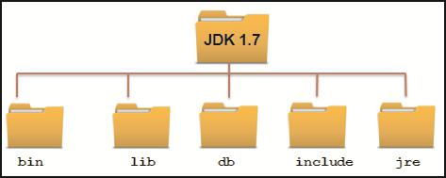

© Aptech Ltd. Introduction to Java/Session 1 41
- Following table lists the common directories that are part of the typical JDK installation:

Directory |  | De cription
bin | Contains tools that are used for developing a
 | Java application, such as compiler and JVM
db | Contai | s a relational database named
 | Apache Derby
include | ontains header files that are used to interact
 | with | applications
 | Centre
jre | Represents the JRE used by the JDK

© Aptech Ltd. Introduction to Java/Session 1 42
- To work with JDK and Java programs, certain setti gs need to be made to the environment variables .

- Environment variables are pointers pointing to programs or other resources. The variables to be configured are as follows:

 PATH - Set to point to the location of Java xecutables (javac.exe and java.
exe).

- CLASSPATH - Specifies the location of the class files and libraries needed by the Java compiler to compile applications.

© Aptech Ltd. Introduction to Java/Session 1 43
- To set the value for the PATH variable, perform the following steps in Windows 7:

  - Right-click My Computer icon on the desktop and then, click Properties from the context menu.

  - Click Advanced system settings link on the left tab.

  - Under Advanced tab, click Environm nt Variables.

  - In the System variables area, select the PATH variable and then, click Edit button to enter the JDK installation folder path.

  - Type path of the bin folder in the Variable Value text box.

  - For example, the path an be:

C:\ WINDOWS\system32;C:\WINDOWS;C:\Program Files\Java\jdk1.7.0\bin

© Aptech Ltd. Introduction to Java/Session 1 44
- To set CLASSPATH variable in Windows 7, perform the following steps:

  - Right-click My Computer icon on the desktop and click Properties from the context menu.

  - Click Advanced system settings link on the left tab.

  - Under Advanced tab, click Environm nt Variables.

  - In the System variables area, click New button.

  - Type CLASSPATH in Variable Name and then, type C:\<jdk _ installation _ folder> in the Variable Value.

© Aptech Ltd. Introduction to Java/Session 1 45
- The development of application software is performed using a programming language that enforces a particular style of programming, also referred to as programming paradigm.

- In structured programming paradigm, the application development is decomposed into a hierarchy of subprograms.

- In object-oriented programming paradigm, applications are designed around data, rather than focusing only on the functionalities.

- The main building blocks of an OOP language are classes and objects . n object represents a real-world entity and a class is a c nceptual model.

© Aptech Ltd. Introduction to Java/Session 1 46
- Java is an OOP language as well a platform used for developing applications that can be executed on different platforms. Java platform is a software-only platform that runs on top of the other hardware-based platforms.

◆ The editions of Java platform a Java SE, Java EE, and Java ME.

- The components of Java SE platform are JDK and JRE. JRE provides JVM and Java libraries that are used to run a Java program. JDK includ s the necessary development tools, runtime environment, and APIs for creating Java programs.

© Aptech Ltd. Introduction to Java/Session 1 47

